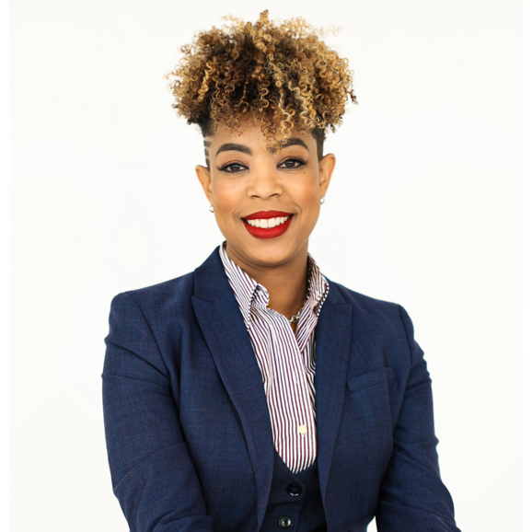
Danielle Sydnor is Founder and CEO of We Win Strategies Group (WWSG). WWSG is a firm dedicated to working with a diverse array of stakeholders to create win-win outcomes for individuals, organizations, and communities.

Sydnor is a respected leader and advocate in Ohio, known for her tireless work in social justice and economic empowerment. With a background in finance, she has held key roles at esteemed institutions like PNC Investments and Merrill Lynch Bank of America Wealth Management, where she focused on financial education and empowerment. Recognized for her leadership, Danielle has received prestigious awards including Crain’s Cleveland Power 150 and Crain's 40 under 40.

Her commitment to community service is evident through her involvement in numerous boards and committees, including as past Board Chair of Eliza Bryant Village and as former President of the Cleveland Branch of the NAACP. She’s currently on the board of Freedom Equity CDFI, ENC and a Commissioner on the Columbus Women’s Commission. Danielle's impact extends beyond her professional roles; she's a sought-after speaker and thought leader, addressing crucial issues like racial equity and entrepreneurship at various forums and conferences.

Sydnor holds a bachelor’s degree in Finance from the University of Phoenix. She is a graduate of the 2020 Class of Leadership Ohio. Danielle is a native of Sacramento, California. Her family moved to Cleveland, Ohio in 1995. She has since proudly deepened her roots in Ohio. She has two sons, Noah and Giles, who are both away at college.

